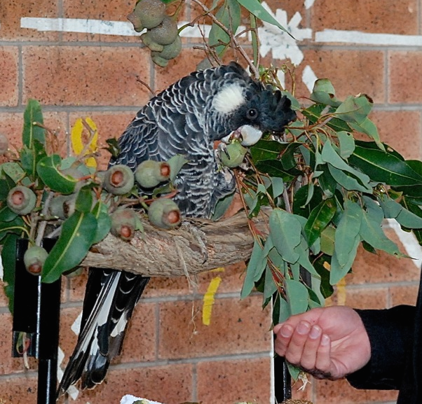

Kaarakin fundraiser
Bring your spare coins and fill in the black cockatoo picture

Thursday 3rd November
In the assembly HALL

PLEASE HELP OUR BLACK COCKATOOS

