BLOG: Getting girls more active – shorts and pants would help
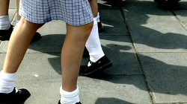
12th Jul 17
by Dr Amanda Mergler, Queensland University of Technology

Enhancing the health and wellbeing of Australian youth is a national priority, and schools are seen as a key place in which to focus our efforts. The Australian Curriculum (ACARA, 2017) provides content descriptors in the areas of personal health, physical activity and movement that all year levels are expected to attain. The overwhelming focus of these descriptors is that children identify, explore and participate in play and outdoor games, and come to understand the benefits of physical activity for their own fitness and the wellbeing of their communities.
Despite this focus and a number of education programs aimed at increasing the physical activity levels of children, many children are not meeting the Australian Physical Activity Recommendations (Commonwealth of Australia, 2004) of 60 minutes of moderate to vigorous intensity physical activity every day (Australian Bureau of Statistics, 2012).
Research (Martin et al., 2008) conducted in primary and secondary government and non-government schools in Western Australia demonstrated that girls did significantly less exercise than boys, including less running around and playing at lunch breaks. In addition, a higher number of secondary school boys (60.7%) as opposed to girls (47.9%) reported actively commuting to school.
In response to the lack of physical activity reported by girls, the researchers identified the lunch break as an ideal time in which schools could work toward increasing girls’ physical activity levels. While this would appear to be reasonable, it fails to take into account a key reason why girls may do so little activity at school - the restriction imposed by their uniform.
In a large number of Australian schools, girls are required to wear dresses and skirts. While uniform requirements are often more accommodating in primary school, secondary schools across the country still largely enforce traditional female uniforms. An analysis I undertook of secondary schools in Brisbane, for example, found that 70% of public schools, and 100% of private schools did not offer girls the option of shorts and pants as everyday wear, requiring instead their female students to wear skirts or dresses.
Research shows that girls wearing dresses to school directly results in them doing less physical activity. An Australian study by Norrish, Farringdon, Bulsara and Hands (2012) recorded the number of steps undertaken by primary school girls and boys over a one month period. For two weeks the students wore their formal uniform (dress for girls, shorts for boys), and for two weeks they wore their sports uniform (shorts for both genders). The results showed that only the girls’ physical activity levels were affected by the type of uniform they wore, with girls doing significantly less exercise when wearing a dress than when wearing the shorts.
In addition, girls themselves identify their uniform as a barrier to participation in physical activity. In two recent Australian studies (Stanley, Boshoff, & Dollman, 2012; Watson, Eliott, & Mehta, 2015), 10 to 13 year old girls reported that their uniform significantly restricted their ability to play at lunchtime (boys did not mention uniform). Watson et al. (2015, p.261) highlighted that, “most girls acknowledged the restrictive nature of dresses and skirts when engaging in physical activity, stating that clothing more appropriate for physical activity would encourage participation”. The girls also articulated the gendered nature of the school uniform, stating that the wearing of shorts made it easier for boys to be active.
In response to the continued requirement of many schools that girls wear skirts and dresses, despite the negative impact it has on their ability to freely engage in physical activity, I have co-founded Girls’ Uniform Agenda (GUA). GUA is an Australia wide group, comprising parents, academics, educators and researchers who advocate choice for girls in school uniform requirements. We aim to:
- Support parents and girls who seek to have uniform policy changes implemented in their schools;
- Encourage school leaders to recognise that girls should be offered a range of suitable formal and informal uniform options, including shorts and long pants;
- Work with uniform suppliers to increase the range of girls’ shorts and pants options available; and
- Campaign for legislative and policy change in this area.
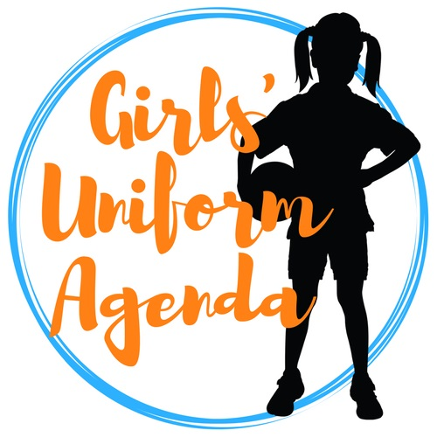
The Girls’ Uniform Agenda website provides a range of resources that parents, students and teachers can use as they seek to generate change in their school’s uniform policies. We have detailed the relevant Education Department policies and legislation for each state, and provide advice and direction on arguments that can be put forward to support the rights of girls to dress appropriately at school.
If we all work together, we can bring schools into the 21st century, and ensure that girls are offered shorts and pants as part of their everyday formal and informal school uniform. Then we will see girls continuing to play, climb and swing at school, and get closer to living in their everyday experience those content descriptors espoused in the Australian Curriculum.

References
Australian Bureau of Statistics. (2012). Australian Health Survey First results, 2011-12. ABS. Accessed at http://www.abs.gov.au/ausstats/abs@.nsf/Lookup/1DA0C56919DE176BC A257AA30014BFB7?opendocument
ACARA. (2017). Australian Curriculum: Health and Physical Education Curriculum. Accessed 23 June, 2017 at http://www.australiancurriculum.edu.au/health-and-physical-education/curriculum/f-10?layout=1
Commonwealth of Australia. (2004). Australia’s Physical Activity Recommendations for 5-12 Year Olds. Department of Health and Ageing.
Martin, K., Rosenberg, M., Miller, M., French, S., McCormack, G., Bull, F., Giles-Corti, B., Pratt, S. (2008). Move and Munch Final Report. Trends in physical activity, nutrition and body size in Western Australian children and adolescents: the Child and Adolescent Physical Activity and Nutrition Survey (CAPANS).
Norrish, H., Farringdon, F., Bulsara, M., & Hands, B. (2012). The effect of school uniform on incidental physical activity among 10-year old children. Asia-Pacific Journal of Health, Sport and Physical Education, 3(1), 51-63.
Stanley, R.M., Boshoff, K., & Dollman, J. (2012). Voices in the playground: a qualitative exploration of the barriers and facilitators of lunchtime play. Journal of Science and Medicine in Sport, 15(1), 44-51.
Watson, A., Eliott, J., & Mehta, K. (2015). Perceived barriers and facilitators to participation in physical activity during the school lunch break for girls aged 12 - 13 years. European Physical Education Review, 21(2), 257-271.

Dr Amanda Mergler is a Senior Lecturer in the School of Early Childhood and Inclusive Education at the Queensland University of Technology (QUT), and a registered psychologist. In 2017, Amanda co-founded Girls’ Uniform Agenda with Ms Simone Cariss to advocate choice of shorts and pants as everyday school uniform for girls at school. Visit their website, Facebook page, or Twitter account for more information.

